NAME:- TALARI VYSHNAVI
USER :- 34725
BATCH :- 5
EMAIL ID :- talari.vyshu@gmail.com

ASSIGNMENT
DEPLOYMENT PROCESS USING PSADT
Topic 1:- PSADT Folder structure and its importance
Here, PowerShell App Deployment Toolkit ( PSADT)uses a well organized folder hierarcy to manage deployment packages and scripts. This structured approach helps in easy management components, making the application deployment process streamlined and less error-prone.

Key Folders:
- Toolkit/: Contains core PSADT module files including scripts, manifests, and language resources; essentially the engine of PSADT.
- Examples/: Holds example deployment scripts serving as templates for new deployments.
- Files/: Stores the application installation files such as .msi, .exe, or .appx.
- SupportFiles/: Contains supporting files like configuration files, certificates, or helper scripts required during deployment.
- Deploy-Application.ps1: The main PowerShell script orchestrating the deployment process, customized per application.
- Deploy-Application.exe: A wrapper to run the PowerShell script with the correct execution policy.
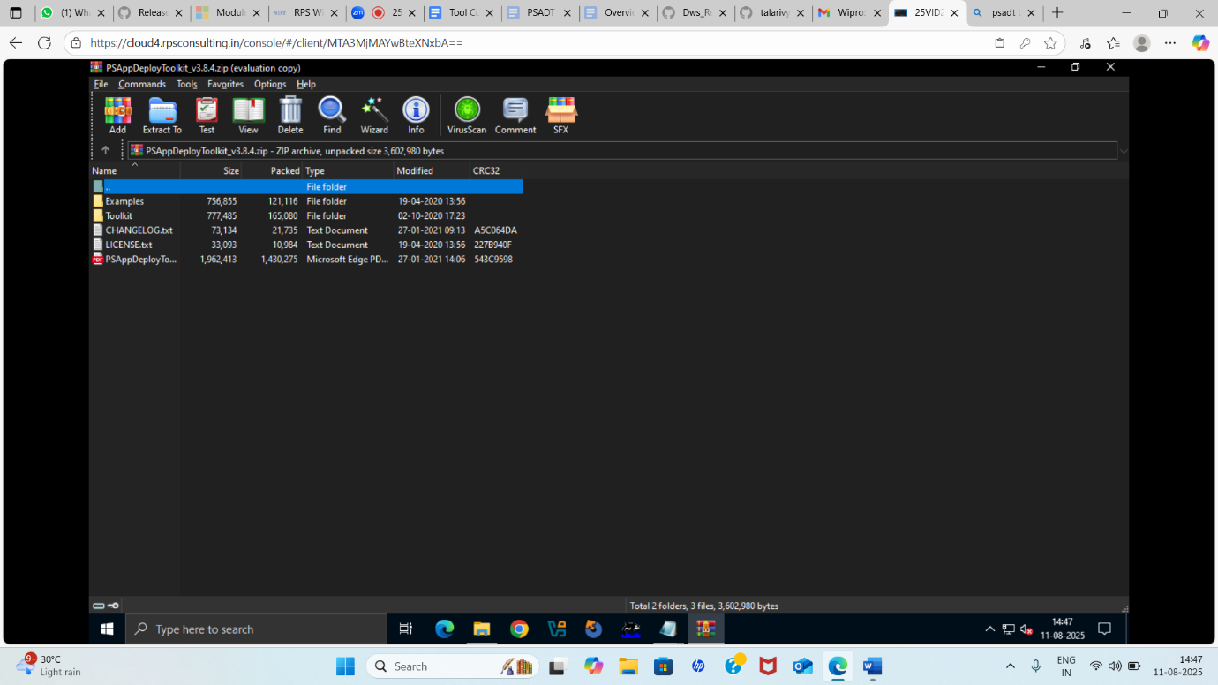
Additional Highlights:
- PSADT supports customization for branding (banners, icons), UI, and scripts.
- Version control (e.g., Git) is recommended to track changes and maintain deployment scripts.
- The modular and flexible structure introduced in PSADT v4 makes managing and customizing deployments easier.
Understanding and using this folder structure effectively allows IT professionals to create, deploy, and manage application deployments with greater ease and consistency.
Topic 2: PSADT .exe application deployment process
When you download PSADT, you’ll get a folder with:
Deploy-Application.ps1 ← Main script you edit
Deploy-Application.exe ← Wrapper to run the .ps1
Toolkit\ ← PSADT core functions
Files\ ← Place for your application installers
AppDeployToolkitConfig.xml
AppDeployToolkitMain.ps1
For deploying an .exe app, you’ll mainly work with:
- *Files* → put your .exe installer here.
- Deploy-Application.ps1 → edit this to install/uninstall.

2. Place Your .exe Installer
Example:
Copy Edit
.\Files\7z2501-x64.exe
This keeps things organized and lets PSADT find the installer easily.

3. Edit Deploy-Application.ps1
Inside the script, find the ##*============================[ INSTALLATION ]============================*## section and add:
PowerShell
Copy Edit
##*============================[ INSTALLATION ]============================*##
# Install 7-Zip silently
Show-InstallationWelcome -CloseApps '7zFM' -AllowDefer
Show-InstallationProgress -StatusMessage 'Installing 7-Zip, please wait...'

Execute-Process -Path "$dirFiles\7z2501-x64.exe" -Parameters "/S"

Show-InstallationPrompt -Message 'Installation complete!' -ButtonRightText 'OK'
For uninstall, in the ##*============================[ UNINSTALLATION ]============================*## section:
powershell
CopyEdit
##*============================[ UNINSTALLATION ]============================*##
# Example uninstall (if your exe supports /uninstall or /S)
Execute-Process -Path "$dirFiles\7z2501-x64.exe" -Parameters "/S" # or actual uninstall command

4. Run the Deployment
You have two ways:
- PowerShell directly:
PowerShell
Edit
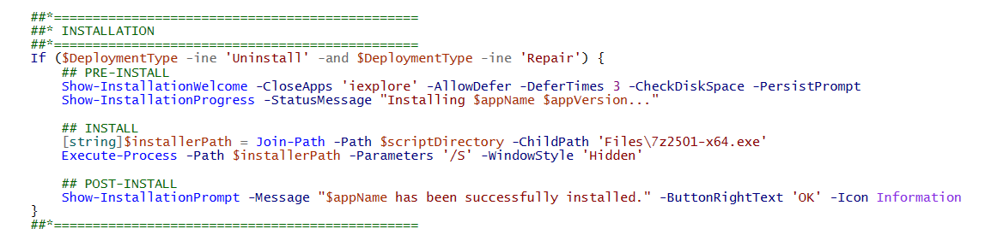
.\Deploy-Application.ps1 -DeploymentType Ins

